Speech pathology

Common terminology and general information

for interpreters and translators

Please use the information below to assist with speech pathology interpreting/translation assignments. Please add to it as you gain more experience working with speech pathologists, and use it in self and group study tasks.

The terminology below is by no means exhaustive or complete. If you are unsure about terminology, please ask the speech pathologist for further explanation before attempting to interpret or translate.

General terminology

|  |  |
| --- | --- |
| Assessment | Conducting test(s) and interviews to determine a person’s abilities/strengths/weaknesses in a specific area |
| Therapy | Treatment/intervention provided to improve a person’s function or skills |
| Delay | When a person’s abilities in a specific area matches what is expected of a person at a younger age |
| Disorder | When a person’s developmental pattern or difficulties in a specific area are atypical compared with what is normally expected |
| Early intervention | Services that aim to provide specialised support to children in the early years (typically from birth to before school entry) |

|  |  |
| --- | --- |
| Severity | The seriousness of a condition or assessment result, or the extent to which an area/ability is impaired. This is often described using the words ‘mild, moderate, severe, profound’ |
| Oral-Motor/Oromotor Evaluation | Evaluation of the mouth structures used for communication and swallowing. This includes the face, lips, tongue, teeth, jaw, hard palate and soft palate. Evaluation often includes assessment of the structure and movement of these areas. |
| Telehealth | Delivering services to locations (e.g. rural/remote settings) through the use of telecommunication, e.g. phone or videoconference sessions |
| Modelling | Demonstrating an appropriate example of a skill so that the person watching the model can copy and learn |
| Key word sign | A communication system that uses a combination of signing, gestures and spoken language. It borrows signs from the sign language of the host country, i.e. Auslan for Australia. |
| National Disability Insurance Scheme (NDIS) | Funding scheme for people under the age of 65 with disability and/or functional impairments with the money to access specialised support and care  [https://www.ndis.gov.au/]( https://www.ndis.gov.au/) |

Anatomy

During communication:

* The lungs push air up the **trachea (wind pipe/airway)** towards **the larynx (voice box)**
* The **vocal cords/folds** are two thin membranes that vibrate against each other inside the voice box as the air passes through. This vibration creates sound.
* The sound then moves up into the mouth, whether it is shaped by the **tongue, teeth, hard palate and lips** to produce speech
* During this process, the **soft palate** also moves up and should seal against the back and sides of the throat to stop air from entering the nasal cavity for all oral sounds
* 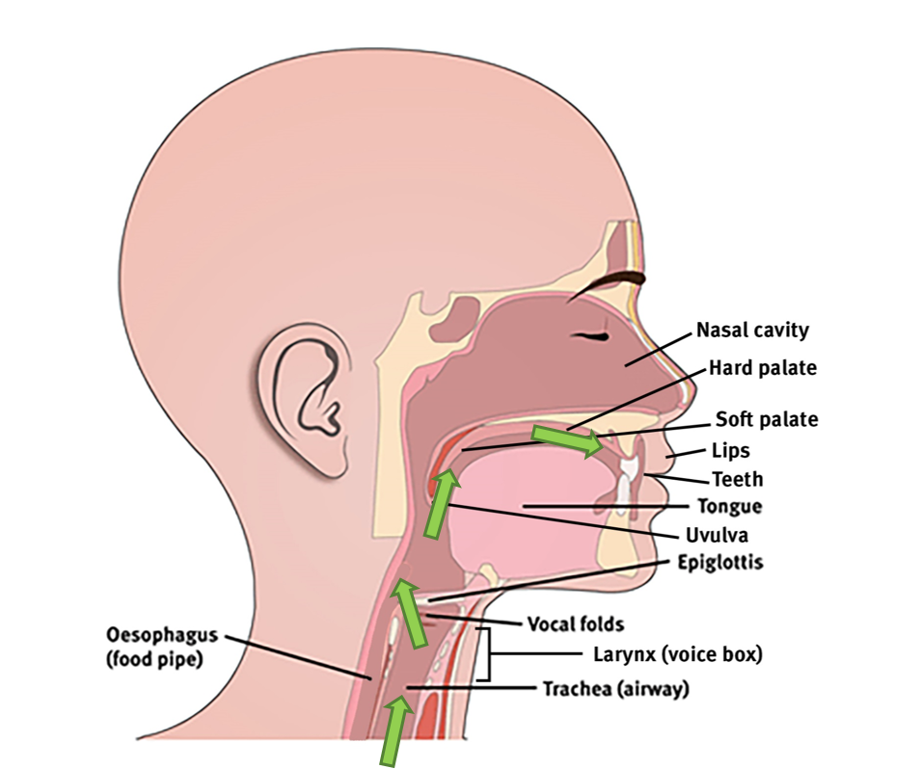For nasal sounds like ‘m’ and ‘n’ and possibly some other sounds in your other languages, the soft palate does not move up and lets some of the air through the nasal cavity

During swallowing, the same parts of the head and neck are used, but in a different way:

* Food enters the mouth through the **lips**
* The **teeth** chew the food
* The **tongue** forms the chewed-up food into a ball-like shape called a ‘bolus’ and when ready, moves the food back towards the throat
* The **soft palate** lifts upwards and backwards, and seals against the back and sides of the throat to stop food from going up into the nose
* The food then travels down and the **epiglottis** closes off the **larynx (voice box)**
* The **vocal folds** also move together to close and protect the airway so that food does not go into the t**rachea (windpipe/airway)** instead of the **oesophagus (food pipe)**
* The food then travels further down into **oesophagus (food pipe)** and into the stomach
* When drinking, the process is similar. Chewing is not needed, and the swallowing process can be must faster than when eating and swallowing foods.

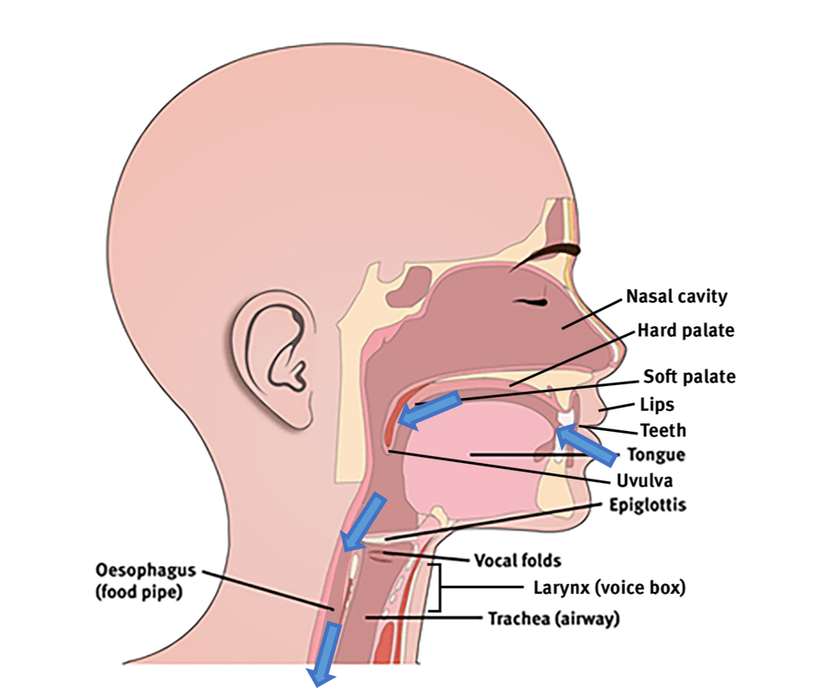

|  |  |
| --- | --- |
| Larynx (voice box) | Organ at the top of the wind pipe involved in breathing, producing sound and protecting food/fluids/foreign matter from entering the airway. Often also called a ‘voice box’. |
| Vocal folds | Two membranous flaps of tissue inside the voice box that come together to produce voice and protect the airway from food/fluids/foreign matter |
| Hard palate | Bony front portion of the roof of the mouth |
| Soft palate (velum) | Soft tissue at the back of the roof of the mouth |
| Cleft lip | Abnormal gap/split in the upper lip, sometimes extending into the nose. |
| Cleft palate | Abnormal gap/split/opening in the roof of the mouth (i.e. at the hard and/or or soft palate) |
| Submucous cleft | A type of cleft palate affecting the muscles underneath the palate (roof of mouth), often difficult to identify as the membrane covering the palate is still intact. |
| Fistula | A hole in the roof of the mouth in either the hard or soft palate, often appearing when a cleft palate surgical repair comes undone. May be associated with food or fluid coming out of the nose during eating or drinking (nasal regurgitation) |

Speech production

|  |  |
| --- | --- |
| Intelligibility | How understandable a person’s speech is to a listener |
| Stimulability testing | Assessment to see if a person can achieve better production of a particular speech sound in isolation, syllables or words |
| Articulation | A person’s ability to use their mouth structures to produce a sound correctly |
| Articulation disorder | Speech errors that are caused because of difficulties using the mouth structures to produce sounds correctly |
| Phonology | The sound structure/system of a language |
| Phonological processes | Predictable sound error patterns. Some sound system/structure errors that children produce are ‘typical’ or ‘age appropriate’ and are normally expected for their age. For more information: <https://www.speech-language-therapy.com/index.php?option=com_content&view=article&id=30:table2&catid=11&Itemid=101> |
| Phonological delay | When a child produces sound system/structure errors that are common in children of a younger age |
| Phonological disorder | Sound system/structure errors that are unusual and not normally produced by children whose speech is ‘typically developing’ |
| Plosive sounds | Short sounds where air ‘explodes’ from the mouth when lip or tongue contacts are released e.g. p, b, t, d, k, g |
| Fricative sounds | Long sounds where air flowing through the mouth generates friction. The lips or tongue partly block/shape the passage of this flowing air e.g. s, z, f, v, sh, zh, th |
| Bilabial sounds | Sounds made with the lips together e.g. m, b, p |
| Interdental sounds | Sounds produced with tongue between upper and lower teeth e.g. th |
| Lateralised sounds | Sounds produced (usually incorrectly) with airflow escaping at the sides of the tongue which can make the sound “slushy” |
| Palatalised sounds | Sounds produced (usually incorrectly) with part of the tongue moved closer to the hard palate during production of a sound |

|  |  |
| --- | --- |
| Velopharyngeal dysfunction (VPD) | During speech and swallowing, the soft palate should elevate and create a seal with the walls of the throat to separate the nasal cavity from the oral cavity. VPD occurs when this mechanism is impaired, and can have a number of different causes (e.g. structural cause, mislearning), or an unknown cause. |
| Motor speech disorder | Difficulties in planning, sequencing and controlling the muscles involved in speech to produce sounds, words, phrases and sentences. This can occur in people of all ages due to neurological (brain) problems. The two main groups of motor speech disorders are apraxia and dysarthria. |
| Apraxia (verbal) | Difficulty planning, sequencing and coordinating speech production. |
| Dysarthria | Difficulties with muscle control that causes weakness, slowness and incoordination during speech production. It can affect respiration (breathing), phonation (making sounds with the voicebox), articulation (producing speech sounds), resonance (shaping speech sounds in the mouth and nasal cavity), and prosody (intonation, stress, tone, rhythm). |

Assessment examples:

* **Child:** Naming pictures while the speech pathologist transcribes the exact sounds in each word
* **Adult:** Reading words, phrases, sentences and paragraphs aloud while the speech pathologist records their responses

Therapy examples:

* **Child:** Playing games with the target sounds included in the activity so the child can practice the correct production many times
* **Adult:** Repeating specific sounds and words, and words in sentences

Language and literacy

|  |  |
| --- | --- |
| Expressive language | Use of verbal and non-verbal communication to convey messages. It focuses on the use of language (vocabulary, grammar, sentence structure) rather than speech sounds |
| Receptive language | Understanding of language, including verbal and non-verbal messages |
| Non-verbal communication | Communicating in ways other than using spoken words, e.g. pointing, gesturing, eye gaze, facial expressions |
| Phonological awareness | Skills involving identifying and manipulating the sound structure of oral language (e.g. counting syllables, rhyme) |
| Pragmatics | Social skills of language e.g. turn-taking, initiating and maintaining conversation, appropriate eye contact |
| Semantics | The aspect of language concerned with meaning e.g. choosing the correct word to refer to the correct object |
| Babble | Sound sequences that infants produce that precede words e.g. ‘babababa’ |
| Word combinations | Infants and toddlers combining two or more words as they develop language |
| Joint attention | Shared focus between two individuals and an object of interest. One usually alerts the other to the object by eye-gazing. |
| Basic grammar and syntax | Please refer to <http://www.lel.ed.ac.uk/grammar/overview.html> |
| Aphasia | Impairments in language (including speaking, understanding, reading and writing) after a brain injury, most commonly a stroke. |
| Word finding difficulties | When a person knows a particular word, but has difficulties finding and using it when they talk. |
| Phonemic paraphasia | An error where a person substitutes the correct word with an incorrect word or non-word that is related to the correct word because of its sounds (e.g. “date” or “klate” for “plate”) |
| Semantic paraphasia | An error when a person substitutes the correct word with an incorrect word that is related to the correct word by its meaning (e.g. “bowl” for “plate”) |

Assessment examples:

* **Young child:** Speech pathologist may write down everything the child is saying during an activity and analyse this later. They may also ask parents specific questions about words the child understands and uses at home.
* **School aged child/adult:** Complete multiple tests that involve listening to instructions, making sentences, reading, spelling and writing

Therapy examples:

* **Young child:** Activities that involve sorting objects into different categories and following longer instructions
* **School aged child/adult:** Practice using conjunctions like ‘and’ and ‘because’ in spoken and written sentences; Reading medicine labels or bus timetables then answering questions to show understanding

Social communication

**Social communication** also differs a lot across different cultures, including:

* Eye contact
* Facial expressions
* Loudness, pitch and tone of voice
* Gestures
* Distance between speaker and listener
* Greetings and addressing others
* Amount of information offered
* Manner (e.g. direct or indirect)

Voice

|  |  |
| --- | --- |
| Phonation | The production of voice at the level of the vocal cords inside the voice box |
| Dysphonia | A problem relating to producing clear voice |
| Resonance | The tone of the voice related to spaces where air can vibrate in the vocal tract, mouth or nasal cavity |
| Hypernasality | Too much nasal tone to the voice |
| Hyponasality | Not enough nasal tone to the voice |
| Vocal nodules | Callous-like growths midway along the vocal cords, which often results in changed voice quality (e.g. hoarseness). Vocal nodules are commonly caused by overuse of the voice or trauma to the vocal folds. |
| Paradoxical vocal fold movement | The vocal folds/cords close abnormally when they should open during breathing and producing voice |
| Vocal fold palsy/paralysis | The vocal folds/cords (one or both) do not move or have limited movement, which can affect voice, breathing and swallow safety |

Fluency/stuttering

|  |  |
| --- | --- |
| Stuttering | A speech disorder that causes interruptions in the rhythm or flow of speech |
| Blocks | A behaviour associated with more severe stuttering which looks like the person is stuck, trying to speak with no sound coming out. |
| Prolongations | Sounds or parts of the word are stretched out (e.g. *Caaaaan I go*) |
| Secondary stuttering behaviours | Other behaviours associated with stuttering which can be verbal or non-verbal |

Primary stuttering behaviours:

* repeated sounds (*c-c-can*)
* repeated syllables (*da-da-daddy*)
* repeated words (*and-and-and*)
* repeated phrases (*I want-I want-I want*)
* prolongations (*caaaaan I go*)
* blocks, which are often silent and are seen when it looks like the person is stuck, trying to speak with no sound coming out.

Secondary behaviours:

* grunts
* small non-speech sounds
* filler words (*um, er, well*)
* pauses
* grimacing
* blinking
* body movements

Swallowing and feeding

|  |  |
| --- | --- |
| Feeding | The whole process of consuming foods and fluids, including interacting with food, behaviours around food, positioning, biting, chewing and swallowing. This word is used to describe a carer/parent feeding a person, or a person feeding themselves. |
| Swallowing | The process of passing food, fluid and foreign matter down the throat and into the oesophagus |
| Dysphagia | Difficulty with swallowing foods and/or fluids |
| Aspiration | When food/fluid/foreign matter passes through the vocal cords/folds and enters the airway |
| Penetration | When food/fluid/foreign matter contacts the vocal cords/folds but does not enter the airway and is expelled |
| Gag | When food/fluid/foreign matter causes a reflex response to expel the matter by contraction of the back of the mouth and throat |
| Choke | When food/fluid/foreign matter obstructs breathing |
| Thin fluids | Fluids like water, milk, clear soups, tea, coffee that do not hold together well in the mouth and have a fast flow rate |
| Thickener | A substance (usually a powder) added to a liquid to make it thicker/firmer, most commonly used for people with swallowing problems |
| Full diet | A person can safely manage to eat all food textures |
| Soft (food texture) | Food texture that is naturally soft or cooked and cut/modified to be soft e.g. banana, eggs, tofu, well-cooked vegetables, moist fish |
| Minced and moist (food texture) | Food texture that is soft, moist, contains very fine lumps (no bigger than ~0.5cm) e.g. mashed banana pieces, mashed meats and blended beans |
| Puree (food texture) | Food that is smooth and free of lumps e.g. custard, yoghurt, blended meats/vegetables/fruits without lumps |

|  |  |
| --- | --- |
| Videofluoroscopic swallow study (VFSS) | A study using an x-ray machine to assess a person’s swallow   * Adults:<http://hi.bns.health.qld.gov.au/allied_health/speech_pathology/documents/vfss-pat-flyer.pdf> * Children:[https://www.childrens.health.qld.gov.au/fact-sheet-videofluoroscopic-swallow-study/?iframe=true&width=100%&height=100%](https://www.childrens.health.qld.gov.au/fact-sheet-videofluoroscopic-swallow-study/?iframe=true&width=100%25&height=100%25) |
| Fiberoptic endoscopic evaluation of swallowing | Procedure of passing a flexible camera down a person’s nose and throat, stopping above their larynx (voice box) to assess their swallowing |
| Nasogastric tube (NGT) | Feeding tube passed through the nose, past the throat and into the stomach |
| PEG tube (Percutaneous endoscopic gastrostomy) | Feeding tube inserted into a surgically created opening in the stomach. It can also be a called other names like G tube and Mickey button. |
| NJ or TPT (Nasojejunal/ transpyloric tube) | Feeding tube passed through the nose, past the throat and into the small intestine |
| JEJ (jejunostomy tube) | Feeding tube inserted into a surgically created opening in the small intestine |
| Malnutrition | Deficiencies, excesses or imbalances in a person’s nutritional intake |
| Oral stimulation | Sensory stimulation around the mouth and inside the oral cavity to promote development of skills related to feeding e.g. sucking, biting |
| Pacing (for feeding) | Responding to the cues of the person who is eating, and adapting the speed by which the food is delivered (e.g. slower presentation of spoon, one spoonful at a time) |
| Positioning (feeding) | Optimal posture of the head, neck, trunk, legs and feet to support eating and drinking |

|  |  |
| --- | --- |
| Reflux (gastroesophageal reflux) | Stomach contents backflows into the oesophagus (food pipe), which can cause pain and vomiting |
| Oral aversion | Persistently avoiding/refusing to interact with foods and drinks |
| Sensory aversion | Persistently avoiding/refusing to interact with foods and drinks based on its sensory properties e.g. refusing to eat wet foods, or only eating foods that are white |
| Tube wean | Process of preparing a person for oral feeding by removing or relying less on a feeding tube |

Common questions speech pathologists ask clients/families:

* What textures are clients eating and drinking?
* Any concerns with swallow safety?
* Is the client self-feeding?
* What equipment are they using?
* Are the recommended food and drink textures appropriate for the client’s culture and family?
* Will the family choose risk feeding (i.e. continue with eating and drinking despite risk of unsafe swallow and complications from aspiration)?
* How is non-oral feeding (e.g. tube feeding) viewed in the community?

For more information

Speech Pathology Australia

Level 1 / 114 William Street

Melbourne VIC 3000

**t** 1300 368 835

**e** office@speechpathologyaustralia.org.au

**w** www.speechpathologyaustralia.org.au

This fact sheet is part of the [*Working effectively with speech pathologists*](http://www.speechpathologyaustralia.org.au/SPAweb/Document_Management/Projects/elearning_for_interpreters_and_translators.aspx) e-learning package

|  |
| --- |
| © State of Queensland (Children’s Health Queensland) 2019  [88x31](http://creativecommons.org/licenses/by-nc/2.5/au/)  This work is licensed under a Creative Commons Attribution Non-Commercial V4.0 International licence. To view a copy of this licence, visit <https://creativecommons.org/licenses/by-nc/4.0/deed.en>  You are free to copy, communicate and adapt the work for non-commercial purposes, as long as you attribute the State of Queensland (Children’s Health Queensland) and comply with the licence terms.  For copyright permissions beyond the scope of this licence contact: Intellectual Property Officer, Queensland Health, email ip_officer@health.qld.gov.au, phone (07) 3708 5069. |
| © State of Queensland (Children’s Health Queensland) 2019  <https://creativecommons.org/licenses/by-nc/4.0/deed.en>  Copyright enquiries: ip_officer@health.qld.gov.au |